|  |  |
| --- | --- |
| **MIT Award smal(bw)** | **Digital Technologies, Manukau Campus**  **User Experience and User Interface Design** |
| **Assessment** | **Project – Version 3** |
| **Due Date:** | **Refer to Canvas** |
| **Assessment  Weighting:** | **This assessment contributes 40% towards the course total.** |
| **Student ID(s):** |  |
| **Student Name(s):** |  |
| **Student E-mail(s):** |  |
| **Statement of Original Authorship**  ***I/We* hereby confirm that this assignment is my/our own work. In addition, the assignment has not previously been submitted for assessment, either in whole or in part, by either myself or any other student at either Manukau Institute of Technology or at any other tertiary institution. To the best of my knowledge and belief, the assignment contains no material which has been previously published or written by another person except where due reference has been made. All unpublished sources of information have been acknowledged. I/We make this statement in full knowledge of an understanding that, should it be found false, I/We will, in most circumstances, receive zero marks for this assignment and may face disciplinary action.**   |  |  | | --- | --- | | **Signed by students:** |  | | **Date:** |  | |  |  | | |

**Learning objective(s)**

This assessment is designed towards assessing learning objectives:

* LO1: Demonstrate an understanding of and apply the concepts of user experience design
* LO2: Analyse, and apply different types of graphical user interface controls
* LO3: Learn and apply user interface design programming language and event-based programming
* LO4: Implement software solutions that have responsive and appealing graphical user interfaces

**Project**

The objective of this project is to design an Android app that can be used to showcase some products and items. Your app should consist of at least three activities as follow:

1. **Activity 1: MainActivity**

This activity enables users to select a category of the items to be shown. For example, assuming that your app deals with cars, MainActivity provides different categories of cars for the user to browse such as Sedan, SUV, Hatchback, MPV, etc. You need to provide at least three categories. A mockup design of this activity is provided below:

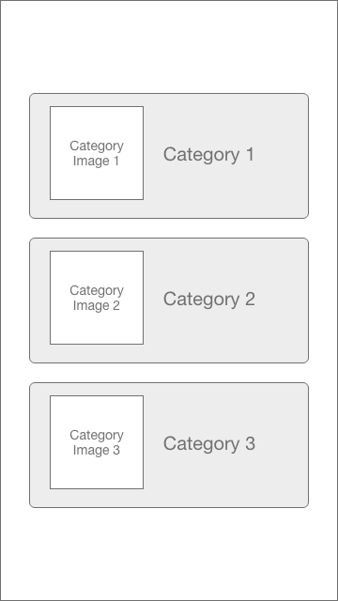

1. **Activity 2: ListActivity**

Upon selecting one of the categories in MainActivty, the app shows ListActivity in which a list of the items, in respect to the selected category, will be provided. In this activity, you need to properly use ListViews or RecyclerViews to dynamically present the information from a data source that stores all of the items. The user should be able to scroll through this list and select one of the items. You need to provide at least ten items per each category. Each item is presented as an object of the model class.

A mockup design of ListActivity is:

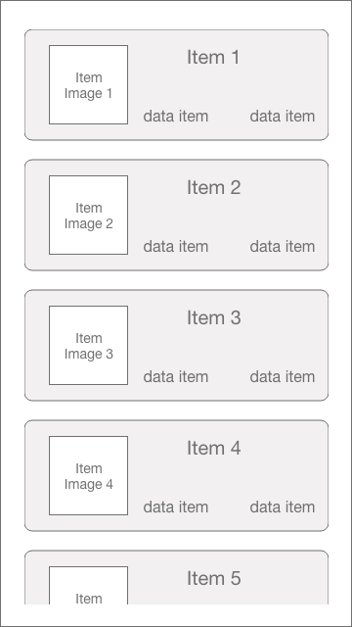

1. **Activity 3: DetailsActivity**

Once users select one of the items in ListActivity, the app should bring up DetailsActivity that provides all detailed information about the selected item. A design mockup of this activity is:

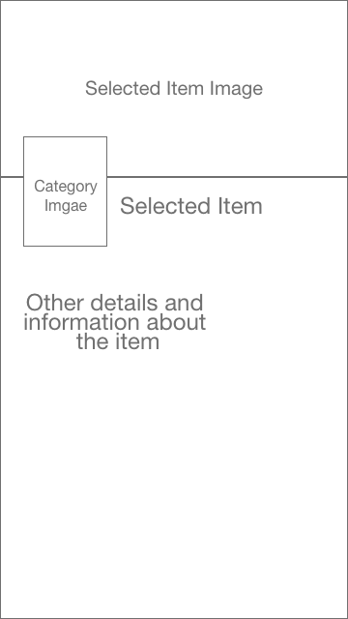

A possible wireframe of this app is provided [here](https://xd.adobe.com/view/1ca1dc5f-df3e-4edd-5547-84d8c4dd3039-6a90/?fullscreen&hints=off).

Note that you the provided design mockups are samples only and you can modify the design.

**You are required to:**

1. Select the context of your app. For example, your app can list cars, books, houses, cell phones, etc.,
2. Design the app that provides the UX explained above,
3. Improve the UX of your app by adding smooth animations and transitions. Your ability to self-train is being evaluated here,
4. Ensure your app has responsive and appealing graphical user interface,
5. Ensure your app follows [Material Design Guidelines](https://material.io/guidelines/),
6. Submit your complete project and source code via Canvas,
7. Present your project to prove the submitted app is your original work (if required).

**Resource(s)**

For the images and icons, you can design them yourself or download them from the internet (providing adequate licensing is provided).

For Information about Android animations and transitions please refer to [here](https://developer.android.com/training/animation/index.html), [here](http://www.androiddesignpatterns.com/2014/12/activity-fragment-transitions-in-android-lollipop-part1.html), and [here](https://www.youtube.com/watch?v=K3yMV5am-Xo).You can also inspire by studying the Material Design Guidelines and browsing the apps [here](https://play.google.com/store/apps/details?id=com.rezanet.learnmaori) and [here](https://play.google.com/store/apps/details?id=com.rezanet.rezashahamiri).

**Testing**

You are required to properly test and debug your app to ensure it runs without a fault and produces the required results.

**Assessment conditions**

* Individual assignment
* Open book
* No time limits (please refer to the due date)

**Marking Scheme and weightage**

|  |  |
| --- | --- |
| **UI Design, Aesthetics, Material Design** | **10 Mark** |
| **Backend Coding** | **10 Mark** |
| **Animations and Transitions** | **10 Mark** |
| **User Experience, Overall Quality and Testing** | **10 Mark** |

**Assessment matrix**

|  |  |  |  |  |
| --- | --- | --- | --- | --- |
|  | **LO1** | **LO2** | **LO3** | **LO4** |
| **UI Design, Aesthetics, Material Design** | √ | √ | √ | √ |
| **Backend Coding** | √ | X | √ | √ |
| **Animations and Transitions** | √ | X | √ | √ |
| **User Experience, Overall Quality and Testing** | √ | √ | √ | √ |

**Submission**

You are required to submit the project code via Canvas by the due date. Compress the entire project folder and submit it over Canvas.

**Presentation**

In order to prove the originality of your code, you may be asked to present and walkthrough your code. During the presentation, you will be asked questions about your submission to prove that the code is your original work.Please note that, if you are required to present your code, your submission will be marked only if you successfully **present** your project. **You must be able to explain your code and answer questions about it.**

**Failure to present the project and/or submit the code means zero mark for this assessment.**

A presentation schedule will be provided via email or Canvas and you are expected to present on time. As such, kindly check your MIT email regularly after you submit your project. Please contact me if your intent is to reschedule your presentation providing that you have a genuine excuse.

**Late submission**

If you have not completed your assignment by the due date, I may allow you to hand it in up to 5-days late. In this case a penalty of **5% per day** will be deducted from your mark.

**Feedback**

Please submit your feedback through Canvas.